- Click Targets Tab and Select Server

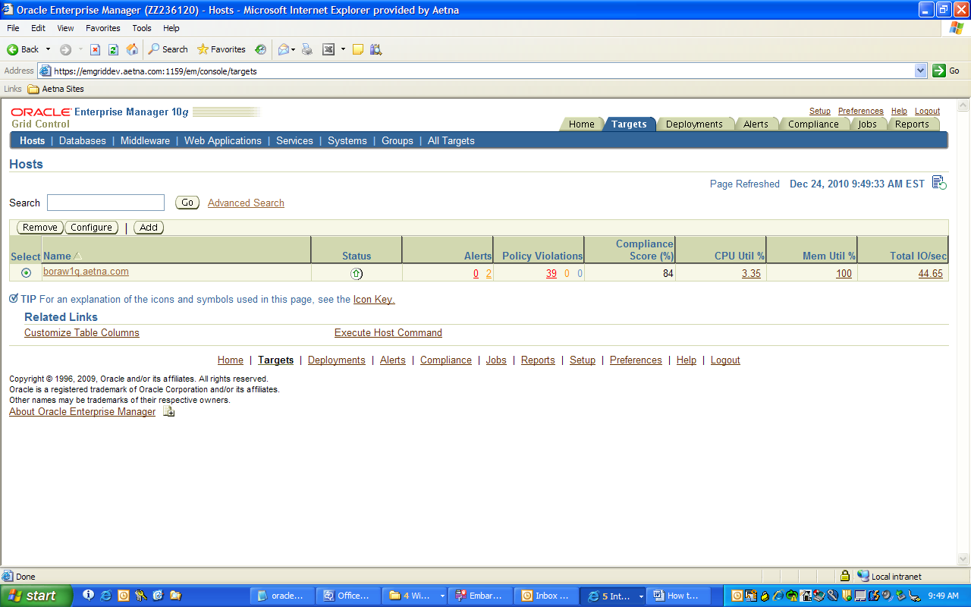

- Click Databases menu (second left)

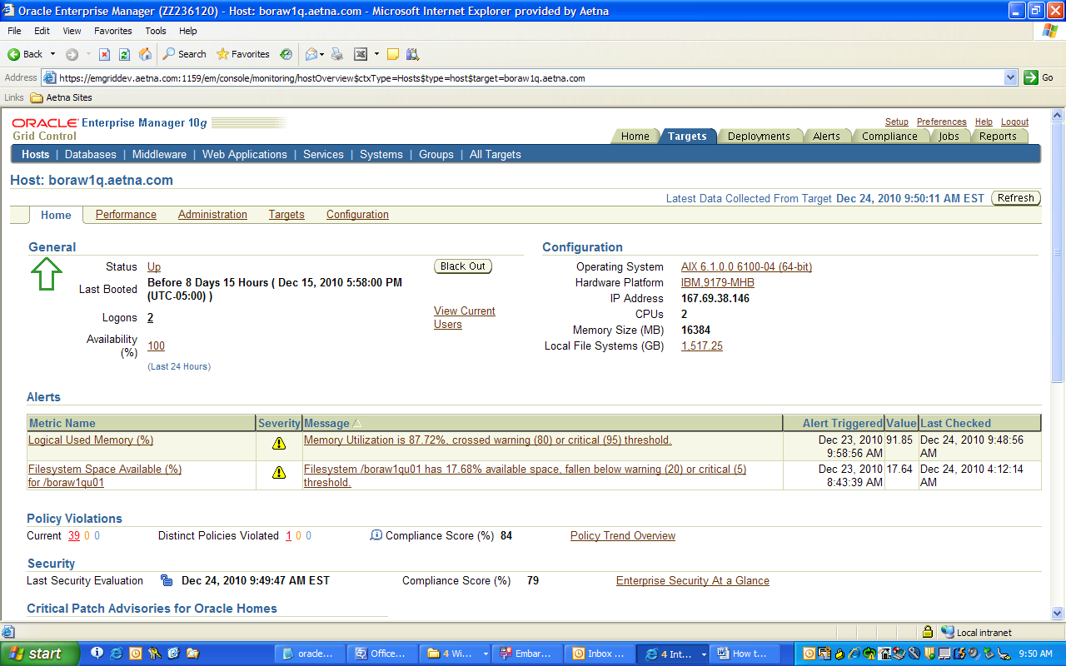

- Select Database and click on it

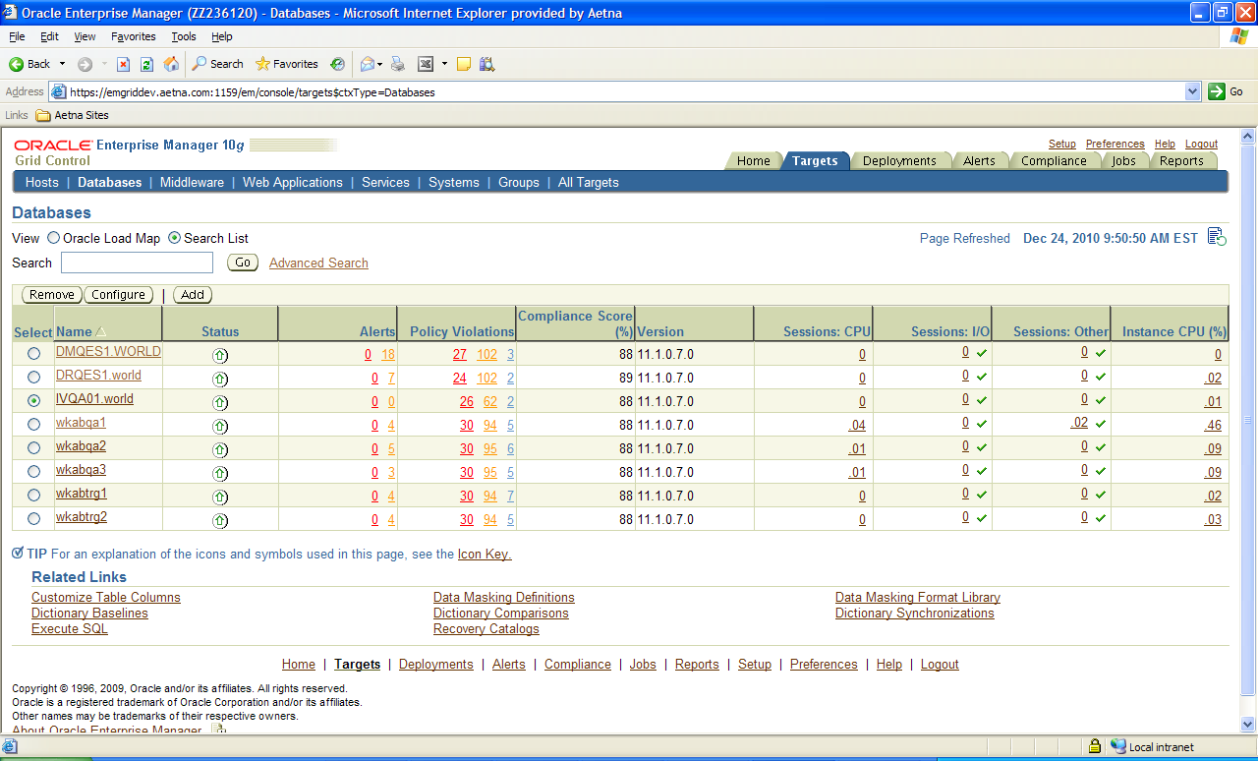

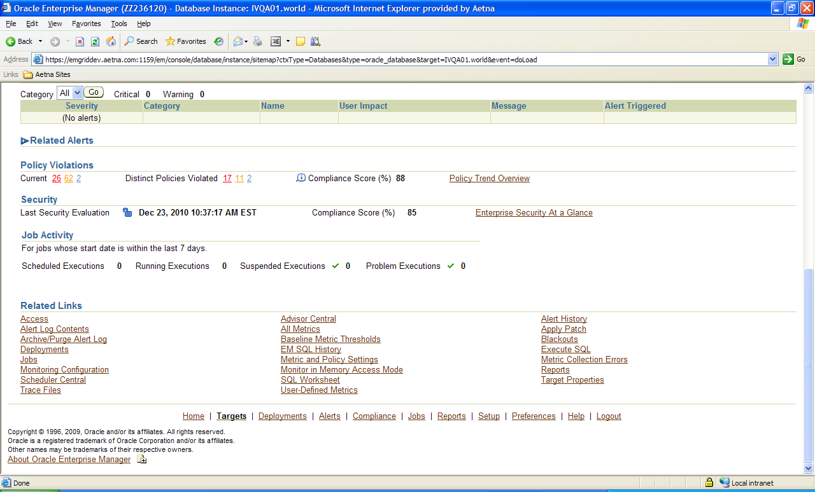

- Click All metrics link (second link on middle)
- Scroll down to Tablespace Full and select Tablespace Used (%) and click it

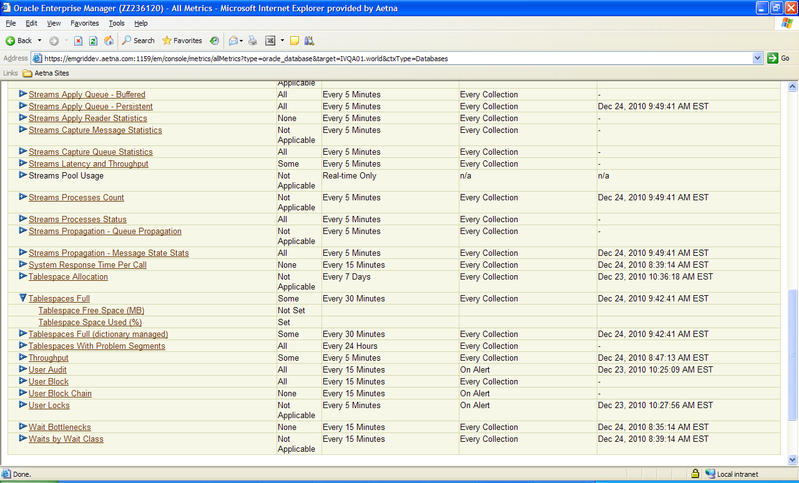

- Select UNDO tablespace link

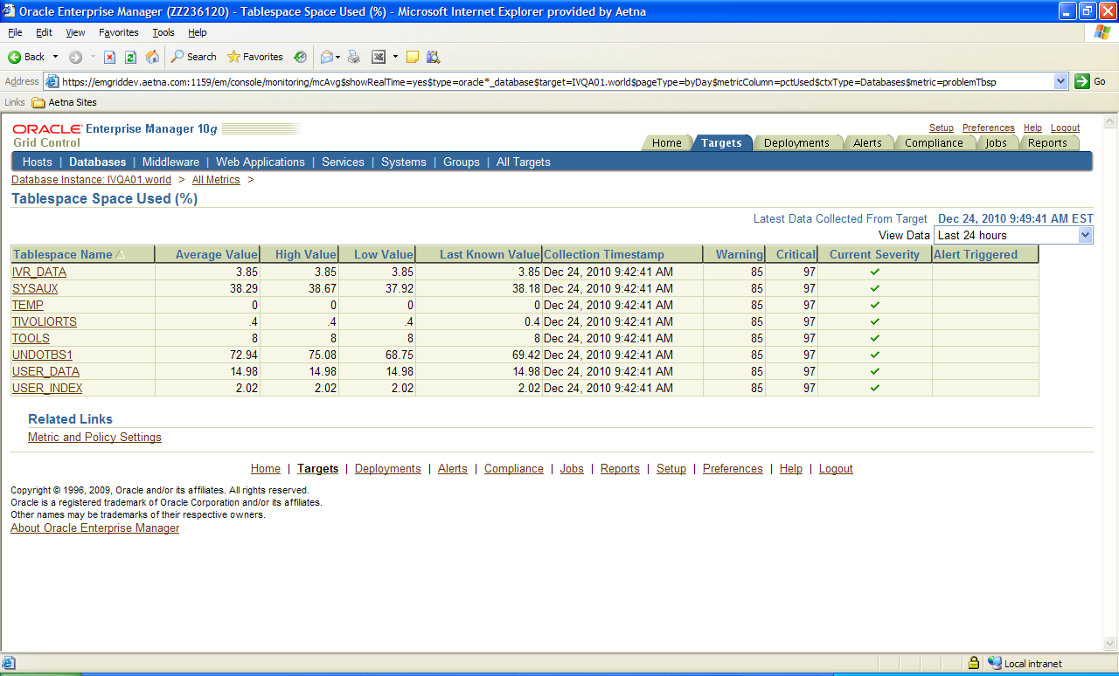

- It may ask to login. Use system account

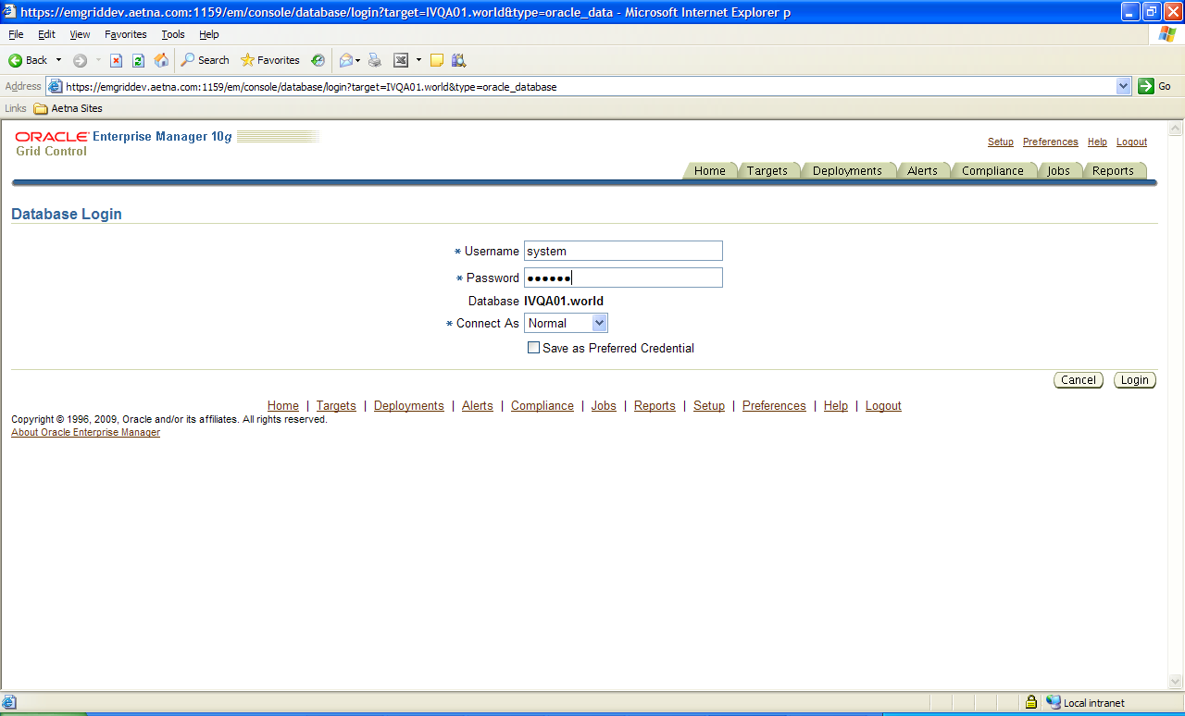

- Click on Threshold tab

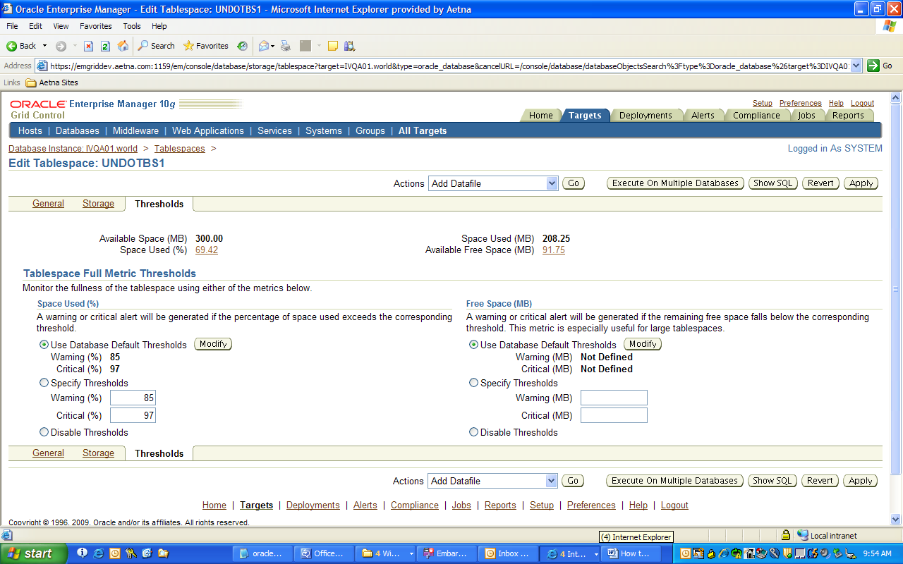

- Select Disable Thresholds and click Apply

